**KS1 Term 3B**

**All Lit Up!**

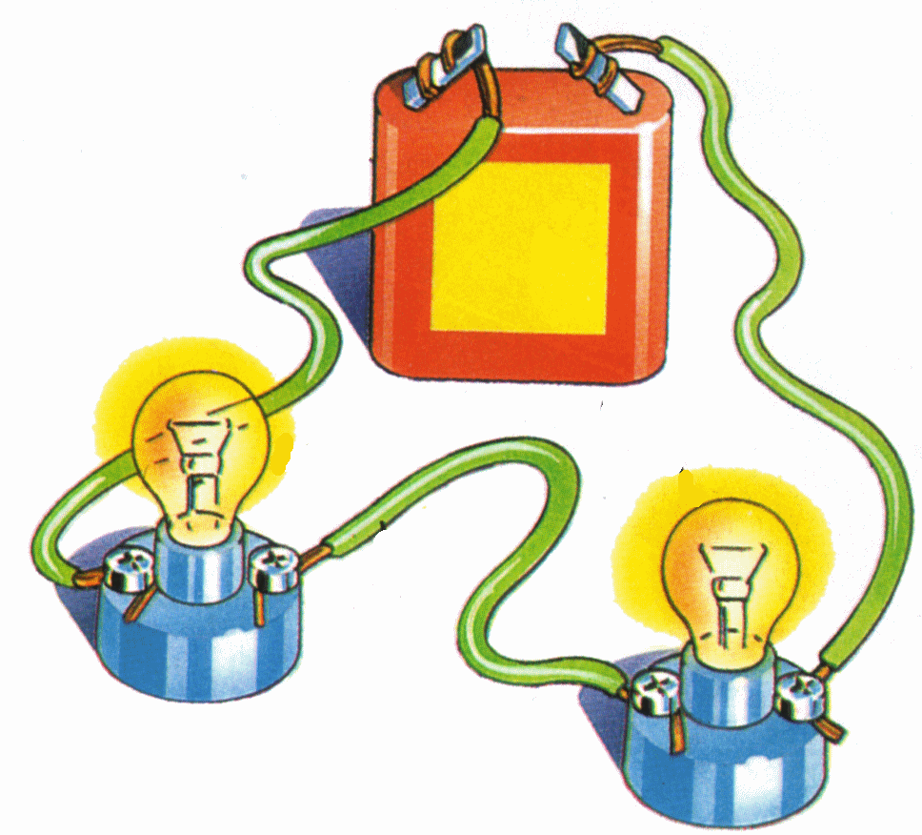

 RE

**Leaders and teachers**

Finding out about figures who have influenced others locally, nationally and globally in religion.

Visitors: people in the community

**Music**

**Storytime, Our bodies, travel and water**

 PHSE

**Relationships**

Covering family; friendships; love & loss; grief; conflict; and cyber safety.

**Changing Me**

Covering life cycles; changing bodies; assertiveness; self-respect; self image; and transition.

 History

Finding out about significant inventions that have changed the world and how we live, eg the invention of electricity, space travel, etc.

Potential visits: Power Station (Interserve); FIGAS - flight

 DT

**The Ultimate Space Rocket**

Finding out about space rockets and how they work. Investigating the types of things they do eg. pull, carry, entertain, etc. Designing the ultimate space rocket.

 Computing

**Visual Information**

Investigating how information is derived from the world around us, including both digital & non-digital sources. Using datalogging devices to explore environmental conditions and organise objects using branching databases. Comparing the ways people and computers might sort objects.

 PE

Athletics, striking and fielding

 Art

**Colour Chaos**

Investigating light and colour in art; looking at warm and cold colours; investigating the colours we see in objects and nature; finding out about key artists; experimenting with a wide range of media.

Geography

**What a sight!**

Using aerial maps, world maps, atlases and globes to investigate the world lit up at night.

Potential Visits: Cartography Dept. (Geo HQ); Power Station (Interserve); Wind Farm (FIG).

 Maths

The Maths curriculum follows a cyclical cycle throughout the year.We follow the Abacus long term plan to ensure coverage throughtout the year.

Potential cross-curricular maths: coordinates, compass directions and directions.

 Science

**Animals**

Learning about common animals, including fish, amphibians, reptiles, birds and mammals; identifying which are herbivores, carnivores and omnivores; describing and comparing the structure the common animals; know that animals have offspring which grow into adults; and finding out about the basic needs of animals for survival.

Potential visits: local farm

 English

This term we will cover: traditional tales from other cultures, humorous stories, letters and books, information texts and poems by the same author.