PE Dance, gymnastics, agility & balance.

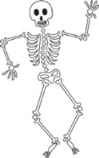

**Our Bodies, Ourselves**

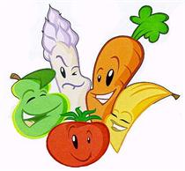

**KS1 Term 1B**

**MUSIC** Ourselves, number, animals and weather.

 History

**Significant People: Nurses & Scientist past and present**

Finding out how people such as Mary Seacole, Marie Curie have contributed to history and what their legacy is today.

 Science

**Human Biology**

Finding out about the human body; naming parts; investigating the senses; knowing why exercise, food and hygiene are important; and knowing what humans need to survive.

Potential visits/visitors: the Med Centre and dentists; the Gym and PTs; Cats and Rats, Chefs.

 English

This term we will cover: stories in familiar settings; stories involving fantasy; labels, lists, signs and posters; information texts; Silly poems; and List poems.

 PHSE

**Being Me in My World**

Building a positive and nuturing school ethos; rights and responsibilities; Learning Charter.

**Celebrating Difference**

Diversity; accepting everyone’s right to ‘difference’; and bullying.

Art



**Portraits**

Learning about key portrait artists such as Picasso, Klee and Warhol; creating a portaits using a range of media – drawing, painting and collage. To know about warm and cool colours.

DT **Dips and Dippers!**

Exploring and evaluating a range of existing products; use the principles of a healthy and varied diet; design and make their own dip with accompanying dippers.

 RE

**Belonging**

Where and how people belong and why belonging is important.

Geography

**Where’s that Penguin?**

Finding out about geography of the school and the local environment (up to Mare Harbour and Fitzroy). What are the human geograhic features in these areas? Investigating aerial maps and creating their own. Learning compass directions and using symbols in keys.

Computing

**Let’s Create**

Begin to explore digital texts, creating their own digital content (still image, word and sound) using a range of devices and software. They develop understanding of some of the devices they use and apply some unplugged programming approaches to support their understanding.

 Maths

The Maths curriculum follows a cyclical cycle throughout the year.We follow the Abacus long term plan to ensure coverage throughtout the year.