 RE

**Story**

Considering the importance of all books and their content; knowing how and why holy books are treated with respect.

 History

**Significant People**

Comparing people in similar roles from the past and present, eg Jacque Cousteau, Ernest Shackleton, Sir Ranulph Fiennes; finding out their achievements are the same but different; investigating ways of finding out about the past.

Potential visits: Dockyard Museum to see Antarctic section.

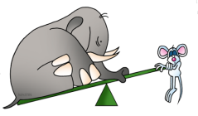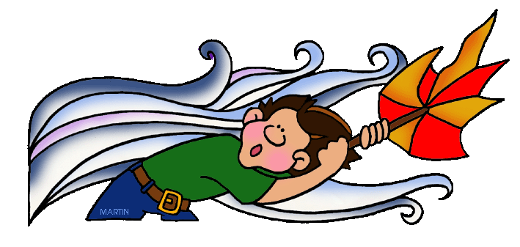

The Forces Within Us

**Music**

**Weather, pattern, water and travel.**

Computing

**Discovering Programming**

Using a range of approaches to develop their understanding algoritms and programming, inlcuding unplugged approaches and simple onscreen and physical devices.

 Maths

The Maths curriculum follows a cyclical cycle throughout the year.We follow the Abacus long term plan to ensure coverage throughtout the year.

DT **Get**

**Moving!**

Investigating how different vehicles move; specifically looking at how vehicles move on snow and ice; designing and building a vehicle to work in Antarctica.

Potential visit: Motor Transport & Dockyard Museum.

PE Multi-skills (Gymnastics) Striking & Fielding

 PHSE

**Relationships**

Discussing families & friendships; love & loss; memories; safeguarding and assertiveness.

**Changing Me**

Looking at life cycles;changing bodies; growing from young to old; assertiveness and self-respect.

Geography

**It’s Cold Out Here!**

Finding out about the oceans, seas and Antarctica; identifying seasonal and daily weather patterns in the UK and the Falkland Islands; looking at the impact of seaons on migration; identifying the location of hot and cold areas of the world in relation to the Equator and the North and South Poles; using basic vocabulary or physical and human features.

Potential visist: Dockyard Museum Antarctic Section

 Art

**Fabricate**

Using a range of materials creatively to design and make a variety of woven and batik-ed placemats.

 English

This term we will cover: fairy stories; letters; poems on a theme – sea; classic contemporary fiction and information texts.

**KS1 Term 3A**

 Science

**Seasonal Changes**

Describing different types of weather; observing the weather; identifying changes over the four seasons; comparing the seasons here to those in the UK.

Potential visits: the Met Office