 RE

**What does it mean to be a Christian in Britain today?**

Find out about how Christians show their faith within their families, within their church communities and their local community.

Find out about some ways in which Christians make a difference in the worldwide community.

 PE

Swimming, athletics and HRE.

**All Lit Up!**

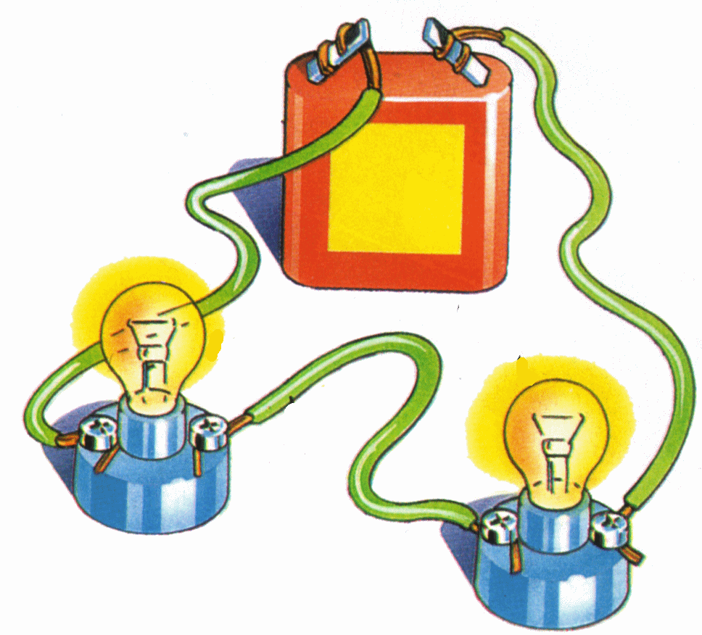

Computing

**Bringing Images to Life**

Developing understanding of the ways that digital images can be edited and transformed. Developing understanding of animation, using digital tools to create their own animation. Using programming software to produce programmed animations, using sequence, repeat and selection.

 English

This term we will cover: stories about times past; persuasive writing; nonsense poetry; stories from other cultures and chronological reports.

 Science

**Electricity and Sound**

Learning about sound, how it is made and what affects volume and pitch. Investigating simple electrical circuits, knowing when circuits are complete, including the use of switches and recognising some conductors and insulators.

**LKS2 Cycle B Term 3**

DT **Light that up!**

Designing and constructing a canvas that incorporates a light in its design.

Art



**Roman Art**

Sculpture and mosaics based on the Roman style.

|  |  |
| --- | --- |
|  | Spanish  Children will work |
| through different scenarios, adding to their Spanish vocabulary. | |

Geography

**Super Power!**

Looking at sustainability and the distribution of natural resources (energy and water), locally on the Falkland Islands.

 PSHE

**Relationships**

Covering family; friendships; love & loss; grief; conflict; and cyber safety.

**Changing Me**

Covering life cycles; changing bodies; assertiveness; self-respect; self image; and transition.

 History

**The Romans -** Finding out about the life of the Romans; their key achievements and their legacy in the modern day.

|  |  |
| --- | --- |
|  | Music  **Focus music** |
| **week** – Visit from music teacher to consolidate whole year’s music learning. | |

 Maths

The Maths curriculum follows a cyclical cycle throughout the year.We follow the Abacus long term plan to ensure coverage throughtout the year.