 RE

**Why is the Bible important fro Christians today?**

Make connections between stories in the Bible and what Christians believe about Creation, the Fall and salvation.

Give examples of how and why Christians use the Bible.

Discuss ideas about how to put things right when something is wrong.

 PE

Swimming, Football and Dance

**Me and My World**

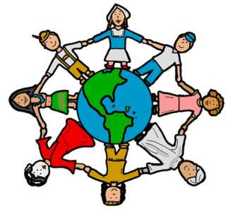

|  |  |
| --- | --- |
|  | Music  **Ukulele** Instruction via VTC of Ukulele – first notes and chords and performance songs. |

 English

This term we will cover: stories by the same author; instructions and explanations; stories from other cultures; information texts; and humerous poems.

|  |  |
| --- | --- |
|  | Spanish  Children will work |
| through different scenarios, adding to their Spanish vocabulary. | |

 Science

**Light**

Finding out how we see and knowing that darkness is the absence of light. Knowing about the perils of the Sun and how shadows are formed. Investigating patterns in the way shadows change.

Geography

**Richness of Life**

Investing the Falkland Islands – weather/climate zones, biomes, eco-systems and mineral distribution.

DT **Kaleidoscopes**

Designing and constructing a kaleidoscope; evaluating their product and suggesting changes for improvement.

 History

Finding out about who the Victorians were and how they lived.

**LKS2 Cycle A Term 1**

 PSHE

**Being Me in My World**

A sense of belonging; welcoming others; rights and responsibilities; learning charters.

**Celebrating Differences**

Similarities and differences; diversity; accepting the right to be different; bullying.

Art **British Artists**



Finding out about key British Artists: past and present. Investigating the themes and techniques they have used. Using those techniques to create their own images.

Computing

**Developing Communication**

Using online communication tools such as emails, blogs and discussion forums to support collaborative learning, safely and respectfully. Using simple sound editing software to record and manipulate sound clips. Complete CEOPs training.

 Maths

The Maths curriculum follows a cyclical cycle throughout the year.We follow the Abacus long term plan to ensure coverage throughtout the year.