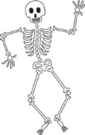

**Our Bodies, Ourselves**

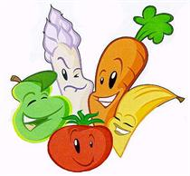

PE Swimming, cricket and football.

 Maths

The Maths curriculum follows a cyclical cycle throughout the year.We follow the Abacus long term plan to ensure coverage throughtout the year.

 RE

**What do different people believe about God?**

Describe some of the ways in which Christians, Hindus and Muslims describe God. Ask questions and suggest some of responses to ideas about God.

Suggest why having a faith or belief in something can be hard but why it makes a difference in some people’s lives to believe in God.

DT **Healthy Lunch, Healthy Me!**

Plan, create and evaluate a healthy lunch box meal.

|  |  |
| --- | --- |
|  | Spanish  Children will work |
| through different scenarios, adding to their Spanish vocabulary. | |

**LKS2 Cycle B Term 1**

Art



**Portraits**

Using pencils to sketch realistic, detailed features, to draw a portrait.

 History

**Changes in Britain from World War II**

Finding out about lifestyle and society changes during and after the war.

Geography

**Here I am!**

Finding out about the human geography – learning about the prime and Greenwich meridians; investigating a region of the UK, London, over time.

|  |  |
| --- | --- |
|  | Music  **Garage Band** |
| Using the iPads to explore and compose music. | |

 English

This term we will cover: fables; stories with familiar settings; instructions and explanations; information texts; and syllabic poems.

Computing

**Authoring**

Using a variety of different software to create digital content; understanding some of the differences between them; selecting and using software to create non-linear content for specific audiences and objectives.

 PSHE

**Being Me in My World**

Building a positive and nuturing school ethos; rights and responsibilities; Learning Charter.

**Celebrating Difference**

Diversity; accepting everyone’s right to ‘difference’; and bullying.

 Science

**Human Biology**

Identifying that humans need the right types and amounts of nutrition; knowing that they cannot make their own food and get nutrition from what they eat; knowing about the human skeleton & muscles and how they support, protect and aid movement.

Potential visits/visitors: the Med Centre and dentists; the Gym and PTs; Cats and Rats, Chefs.