 History

**The Aztecs**

Finding out about significant events and people in the Aztec period of South American history; investigating their legacy today.

Geography

**Let it Flow!**

Learning about the water cycle and its role in river formation.

**LKS2 Cycle A Term 3B**

PE Swimming, Athletics and Rounders.

 RE

**What significant experiences mark our journey through life?**

What are the significant milestones on life’s journey?

Consider the symbols and rituals, value and meaning of ceremonies which mark milestones in life.

|  |  |
| --- | --- |
|  | DT **Rainwater**  **Collectors!** |
| Design and make rainwater collectors – think about the reasons for doing so and the most environmentally sound method of making one. | |

 Art

**Aztec Art**

Using different medium, including clay, to recreate Aztec art.

 Maths

The Maths curriculum follows a cyclical cycle throughout the year.We follow the Abacus long term plan to ensure coverage throughout the year.

Computing

**Programming and Games**

Exploring simulations; exploring programming; decomposing tasks and creating and debugging algorithms to solve them; understanding how algorithms support the programming process; writing programs to achieve specific objectives; understanding and using sequence, selection and repetition; testing, debugging and refining their programs.

|  |  |
| --- | --- |
|  | Spanish  Children will work |
| through different scenarios, adding to their Spanish vocabulary. | |

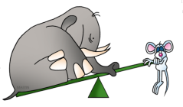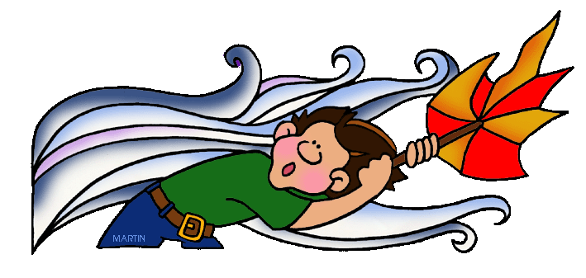

The Forces Within Us

|  |  |
| --- | --- |
|  | Music  **Focus music** |
| **week** – Visit from music teacher to consolidate whole year’s music learning. | |

 PSHE

**Relationships**

Discussing families & friendships; love & loss; memories; safeguarding and assertiveness.

**Changing Me**

Looking at life cycles;changing bodies; growing from young to old; assertiveness and self-respect.

 English

This term we will cover: adventure stories; plays and dialogues; persuasive writing; non-chronological reports and traditional poems.

 Science

**Forces and Magnets**

Comparing how things move over surfaces; noticing that magnet forces don’t need contact between surfaces; observing how magnets attract and repel each other; group everyday materials according to whether they attract magnets.

Potential visits: Motor Transport and the Royal Engineers