 Science

**Electricity**

Investigating how the number or voltage of the cells affects the brightness of a bulb or loudness of a buzzer. Comparing and reasoning for variations in how components function. Recognising and using when creating simple circuit diagrams.

Potential visits: Power Station (Interserve)

**All Lit Up!**

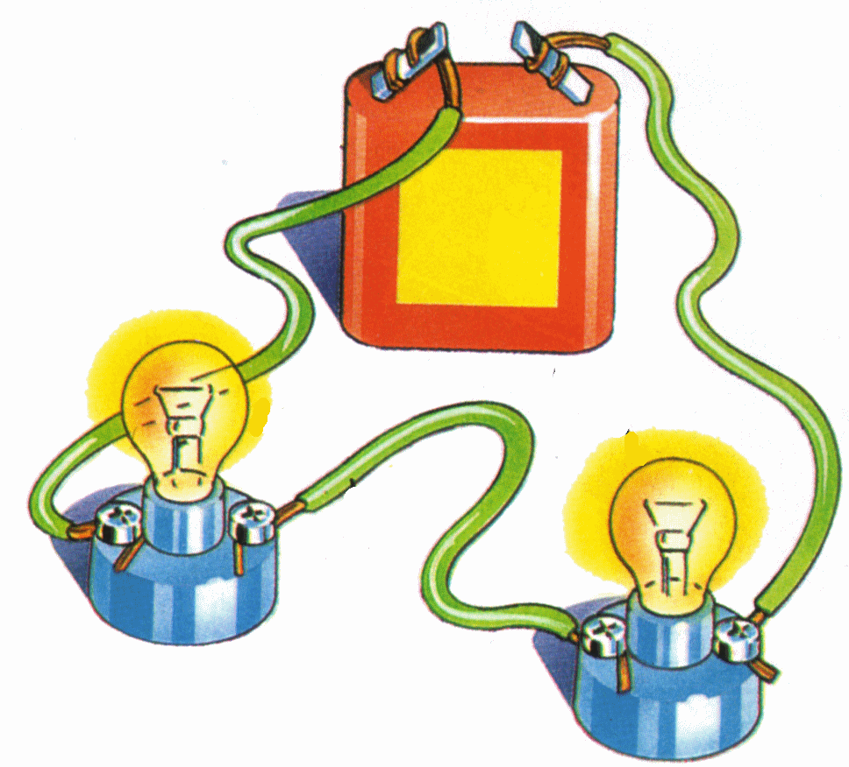

 RE

**Beliefs in Action in the World**

Finding out how religions and beliefs respond to global issues of human rights, fairness, social justice and the importance of the environment in Christianity.

Visitors: people in the community

Art



**The Art of the Anglo Saxons**

Finding out about the art, architecture, embroidery, metal work and manuscripts with the aim to create artwork pieces inspired by the Anglo Saxons.

 DT

**Light that up!**

Designing and constructing a battery operated light/lantern inspired by Sinbad.

Geography

Looking at the physical geography of the Falkland Islands with regards to natural resources. Investigating climate zones, vegetation belts and biomes locally and globally.

 Hi story

**The Anglo-Saxons & their Legacy today**

Finding out about key events in Anglo Saxon history in the UK; learning about Anglo-Saxon laws and justice; investigating their legacy today.

 PHSE

**Relationships**

Covering family; friendships; love & loss; grief; conflict; and cyber safety.

**Changing Me**

Covering life cycles; changing bodies; assertiveness; self-respect; self image; and transition.

**UKS2 Term 3B**

 PE

Swimming, athletics and gym

 Computing

**Sound Works**

Creating soundscapes, incorporating diferent content. Targeting work to meet the needs of specific audience and gather feedback from that audience.

 Maths

The Maths curriculum follows a cyclical cycle throughout the year.We follow the Abacus long term plan to ensure coverage throughtout the year.

 English

This term we will cover: classic fiction; chronological reports; poet study – Emily Dickinson; modern classic fiction; and information texts.