 Maths

The Maths curriculum follows a cyclical cycle throughout the year.We follow the Abacus long term plan to ensure coverage throughtout the year.

**Me and My World**

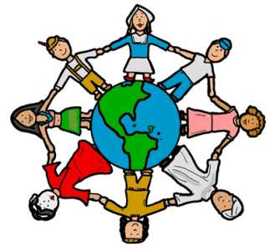

 RE

**Journeys**

Exploring the idea of life as a journey and how events that take place along the way can bring people closer to God. Consdier ideas about death and what comes after – how we deal with bereavement and mark the significance of a life lived.

 History

Finding out about the Victorian sea farers; their connection to the Falkland Islands; and their legacy on the Island and the world today.

 PHSE

**Being Me in My World**

A sense of belonging; welcoming others; rights and responsibilities; learning charters.

**Celebrating Differences**

Similarities and differences; diversity; accepting the right to be different; bullying.

**UKS2 Term 1A**

 PE

Swimming, Football and Dance

 Science

**Earth and Space**

Finding out about the movement of Earth and other planets in our Solar System; understanding the movement of the Moon and the how day and night happen.

**Light**

Knowing that light travels in straight lines and how we see objects, as well as how shadows have the same shape as their objects.

Geography

**Richness of Life**

Investing a variety of locations (e.g. Las Vegas, Kibera, Easter Island, Antarctica, Australia) to find out about climate zones, biomes, eco-systems and mineral distribution.

Computing

**Staying Connected**

Using blogs for collaborative projects in school, uploading different types of digital content, while checking copyright and crediting sources. Working as a class to build a wiki around a class topic, taking editorial responsbility for their work. Knowing the school’s eSafety rules and encouraging other children to keep safe online – CEOPs.

DT **Bird Feeders/Boxes**

Designing and constructing a variety of bird feeders and boxes to hang around the school site and in the Forest School area.

Art **British Artists**



Finding out about key British Artists: past and present. Investigating the themes and techniques they have used. Using those techniques to create their own images.

 English

This term we will cover: classic fiction; recounts; Slam poetry; biographies and autobiographies; and instructions and explanations.