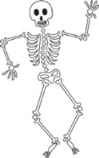

**Our Bodies, Ourselves**

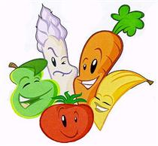

PE

Cricket and Football

 PHSE

**Being Me in My World**

Building a positive and nuturing school ethos; rights and responsibilities; Learning Charter.

**Celebrating Difference**

Diversity; accepting everyone’s right to ‘difference’; and bullying.

 Science

**Human Biology and Animals**

Describing the changes as humans develop to old age; naming parts of the human circulatory system; recognising the impact of diet, exercise, drugs and lifestyle; describing the way nutrients and water are transported in humans and animals.

 History

World War II

Investigating the reasons for the start of the war, looking into the affects and consequences of key moments in the build up to the War.

 English

This term we will cover: historical stories; significant authors; recounts; instructions and explanations and choral or performance poetry.

**UKS2 Term 1B**

DT **The Great Bread Bake Off!**

Finding out about the history of bread and important people in its development; designing a new type of bread; selecting ingredients and equipment to make bread.

Art



**Bodies**

Using different materials such as felt-tip pens and charcoal to draw the human form; using sketchbooks effectively; making 3D models; learning about artists such as Giacometti, Henry Moore & Julian Opie

Computing

**Morphing Image**

Exploring 3D drawing tools and consider how these are used in the wider world; using storyboards to create live film and animations for specific audiences; demonstrating their understanding ofcopyright and ownership; crediting the sources of materials they use.

 Maths

The Maths curriculum follows a cyclical cycle throughout the year.We follow the Abacus long term plan to ensure coverage throughtout the year.

Geography

**Here I am!**

Geography of WWII – Finding out about the War’s impact on physical and human geography, comparing different areas post war.

 RE

**Religion and the Individual**

What is expected of a person in following a religion or belief in Christianity, Sikhism and Judaism.