 RE

**Teachings and Authority**

Considering the sources of guidance in our own lives and those of Christian and Muslim faith; reflecting on the idea of God and the relationships people have with Him.

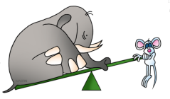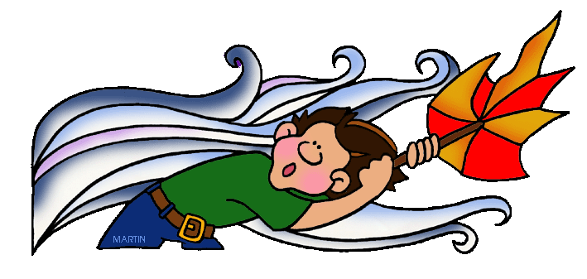

The Forces Within Us

Computing

**Robotics and Systems**

Investigating automated systems in the wider world and considering the programming instructions which could control them; creating and debugging algorithms and then using different programming languages to write the related programs; programming physical devices, controlling inputs and outputs; using sequence, selection, repetition and variables in their programs.

 Maths

The Maths curriculum follows a cyclical cycle throughout the year.We follow the Abacus long term plan to ensure coverage throughtout the year.

 PHSE

**Relationships**

Discussing families & friendships; love & loss; memories; safeguarding and assertiveness.

**Changing Me**

Looking at life cycles;changing bodies; growing from young to old; assertiveness and self-respect.

**UKS2 Term 3B**

PE Swimming, Athletics and Rounders.

Geography

**Let it Flow!**

Investigating the rivers of the world, such as the Amazon and the San Carlos (Falkland Islands); finding out about how they form, their key features and the role they play in the environment. Revision of the water cycle in terms of how it assists with river formation

 Science

**Forces**

Learning about gravity; identifying the effects of air resistance, water resistance and friction; recognising that some mechanisms, including levers, pulleys and gears allow a smaller force to have a greater effect.

Potential visits: Motor Transport and the Royal Engineers

 History

**The Mayans**

Finding out about significant events and people in the Mayan period of Central American history; investigating their legacy today.

 Art

**South American Art**

Learning about artists such as Frida Khalo, Leonora Carrington, Diego Rivera and Carlos Paez Vilaro; sculpting clay; using colour in drawing; and making a collage.

DT **Marbulous**

**Structures!**

Exploring structures; selecting materials; applying understanding of structures; in the context of designing and building a marble run.

 English

This term we will cover: classic novels; persuasive writing; debate poetry and poetry that tells a story; science fiction; and the power of imagery.