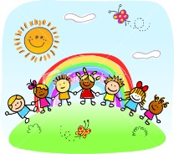

**We are Unique!**

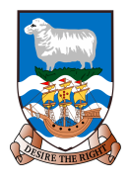

 PE

Swimming, Athletics and Handball

 RE

**Christianity**

Tracing the story of the beginning of the Christian religion, considering the significant people, events and ideas.

Visitors: people in the community

History

Falkland Island History: The 1982 Conflict. Researching the events leading up to the conflict and the resulting consequences. Analysis of politica; agenda of the time and the legacy today.

PHSE

**Dreams and Goals**

Covering goals to success; challenges; over coming obstacles and aspirations.

**Healthy Me**

Covering emotional and physical health.

Science

**Properties and Changes of Materials**

Investigating everyday materials for their properties; knowing that some materials dissolve and can be recovered; separating mixtures; explaining how the properties of materials lend them to particular uses; demonstrating reversible changes and explaining that some changes result in the formation of new materials.

Possible visits: Interserve and DIO to research materials used and their properties.

Computing

**Data Matters**

Investigating the concept of ‘big data’ sharing its application in the world for such areas as meteorology, mapping, traffic flow, etc. Reviewing how data and information are stored and searched on computer networks. Investigating digital footsprints & ways of using online tools resopnsibly. Designing, creating and searching flat-file databases, producing reports and considering accuracy.

Maths

The Maths curriculum follows a cyclical cycle throughout the year.We follow the Abacus long term plan to ensure coverage throughtout the year.

 DT

**Automata Animals**

Designing and constructing mechanisms where by animals move using cams and wheels.

* Art

**Wild Life**

Drawing Sea Animals; creating prints based on a variety of textures; and sculpting sea animals in a variety of medium such as clay and paper.

 English

This term we will cover: Genre fiction; Argument and Debate; Drama (Shakespeare); Reports and journalistic writing; and Poetic Style.

UKS2 Term 2A

Geography

**Food for Thought**

Looking at the distribution of natural resources (food), locally and globally; investigating land use in the Falkland Islands; and researching where our food comes from.